**HOMEPAGE CODE:**

**HTML CODE: home.html**

<html lang="en">

<head>

<meta charset="UTF-8">

<meta name="viewport" content="width=device-width, initial-scale=1.0">

<title>Hamburger Menu with Side Navigation</title>

<link rel="stylesheet" href="styles.css">

</head>

<body>

<div class="hamburger-menu" onclick="toggleSidenav()" aria-label="Toggle menu">

<span></span>

<span></span>

<span></span>

</div>

<div class="overlay" id="overlay" onclick="closeSidenav()"></div>

<nav class="sidenav" id="sidenav" aria-hidden="true">

<h2>Menu</h2>

<a onclick="navigateToSection('home')">Home</a>

<a onclick="navigateToSection('login')">Login</a>

<a onclick="navigateToSection('register')">Register</a>

<a onclick="navigateToSection('contact')">Contact</a>

</nav>

<div class="hero" onclick="closeSidenav()">

<div class="hero-text">

<h2>Welcome to the Scholarship Portal</h2>

<p>Explore opportunities and resources for students to apply for scholarships and financial aid.</p>

</div>

</div>

<script src="scripts.js"></script>

</body>

</html>

**JAVASCRIPT CODE: script.js**

function toggleSidenav() {

const sidenav = document.getElementById('sidenav');

const overlay = document.getElementById('overlay');

sidenav.classList.toggle('active');

overlay.classList.toggle('active');

}

function closeSidenav() {

const sidenav = document.getElementById('sidenav');

const overlay = document.getElementById('overlay');

sidenav.classList.remove('active');

overlay.classList.remove('active');

}

function navigateToSection(sectionId) {

closeSidenav();

const sections = document.querySelectorAll('.section');

sections.forEach(section => {

section.classList.remove('active');

});

document.getElementById(sectionId).classList.add('active');

}

**CSS CODE: style.css**

/* General Styles */

body {

margin: 0;

font-family: Arial, sans-serif;

display: flex;

flex-direction: column;

height: 100vh;

overflow: hidden;

}

/* Hamburger Menu */

.hamburger-menu {

position: absolute;

top: 10px;

left: 10px;

display: flex;

flex-direction: column;

justify-content: space-between;

width: 30px;

height: 20px;

cursor: pointer;

z-index: 1000;

}

.hamburger-menu span {

display: block;

height: 4px;

width: 100%;

background-color: #FFFFFF;

border-radius: 2px;

transition: 0.3s ease;

}

.hamburger-menu:hover span {

background-color: #CCCCCC;

}

/* Side Navigation */

.sidenav {

height: 100vh;

width: 250px;

background-color: #333;

color: white;

display: none;

flex-direction: column;

padding: 20px;

position: fixed;

top: 0;

left: 0;

box-shadow: 2px 0 5px rgba(0, 0, 0, 0.2);

z-index: 999;

}

.sidenav.active {

display: flex;

}

.sidenav h2 {

margin: 0 0 20px;

text-align: center;

border-bottom: 1px solid #555;

padding-bottom: 10px;

}

.sidenav a {

color: white;

text-decoration: none;

margin: 10px 0;

padding: 10px;

border-radius: 5px;

transition: background-color 0.3s;

cursor: pointer;

}

.sidenav a:hover {

background-color: #575757;

}

/* Overlay */

.overlay {

position: fixed;

top: 0;

left: 0;

width: 100%;

height: 100%;

background: rgba(0, 0, 0, 0.5);

display: none;

z-index: 998;

}

.overlay.active {

display: block;

}

/* Hero Section */

.hero {

display: flex;

justify-content: center;

align-items: center;

width: 100%;

height: 300px;

margin: 0 auto;

background: url('sdnb.png') no-repeat center center/cover;

position: relative;

color: white;

}

.hero-text {

text-align: center;

font-size: 28px;

font-weight: bold;

z-index: 1;

background: rgba(0, 0, 0, 0.5);

padding: 10px 20px;

border-radius: 10px;

}

.hero-text p {

font-size: 16px;

line-height: 1.5;

}

@media (max-width: 768px) {

.hero {

height: auto;

padding: 10px;

}

.hero-text {

font-size: 20px;

}

.sidenav {

width: 200px;

}

}

**IMAGE: sdnb.png**

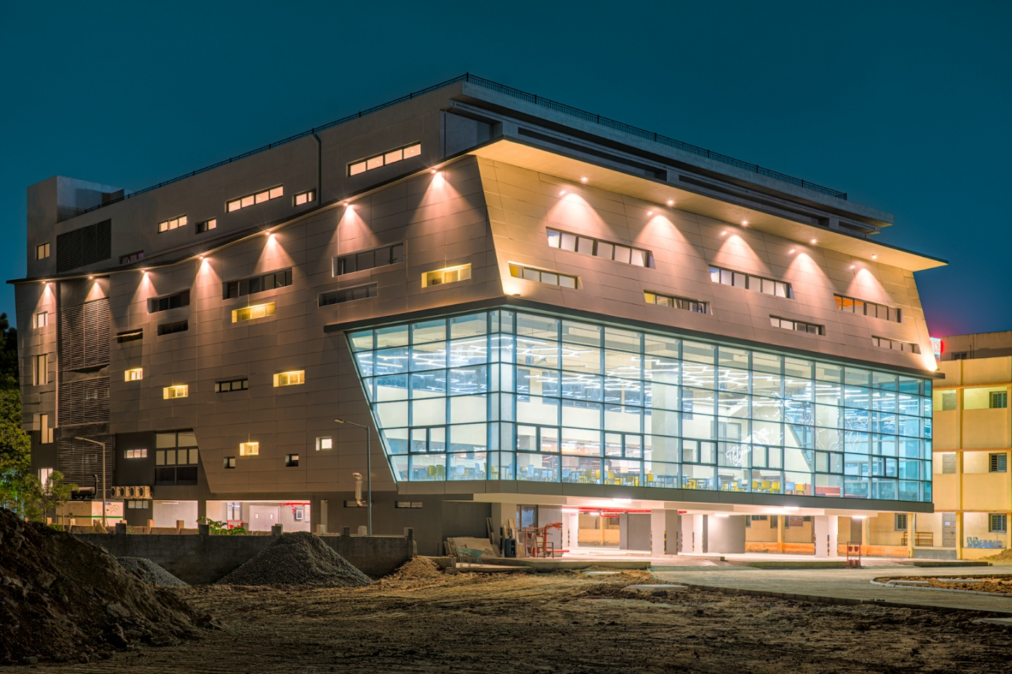

**OUTPUT:**

